Lesson 16
Worksheet (WS)

Unit 2020 : Electrical science
Worksheet 10: Series/parallel resistive circuits

Work sheet (WS) 2
Generic information: 2
WS Question one 3
WS Question two 4
WS Question three 5
WS Question four 5
WS Question five 8
WS Question six 9
WS Question seven 9
WS Question eight 10
WS Question nine 11
Question ten 12

Work sheet (WS)

Generic information:

In a series circuit we add all of the resistance/resistors.

Whereas, in a Parallel circuit we use the formula.

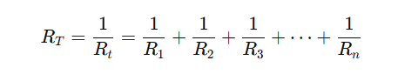

WS Question one

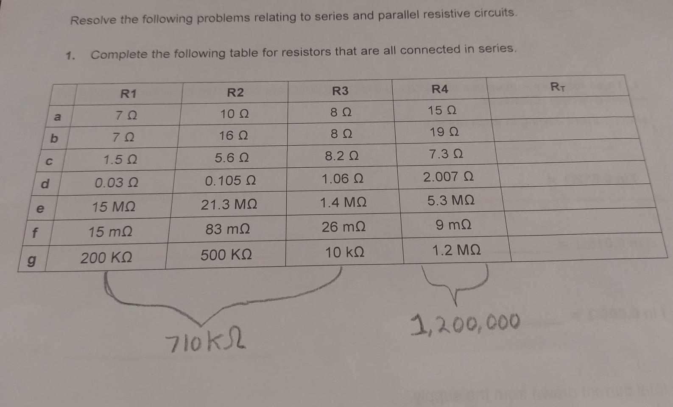

 | R1 | R2 | R3 | R4 | Rt
a | 7 Ω | 10 Ω | 8 Ω | 15 Ω | 40 Ω
b | 7 Ω | 16 Ω | 8 Ω | 19 Ω | 50 Ω
c | 1.5 Ω | 5.6 Ω | 8.2 Ω | 7.3 Ω | 22.6Ω
d | 0.03 Ω | 0.105 Ω | 1.06 Ω | 2.007 Ω | 3.202Ω
e | 15 MΩ | 21.3 MΩ | 1.4 MΩ | 5.3 MΩ | 43MΩ
f | 15 mΩ | 83 mΩ | 26 mΩ | 9 mΩ | 133MΩ
g | 200 KΩ | 500 KΩ | 10 kΩ | 1.2 MΩ | 1.91MΩ

Question one working out

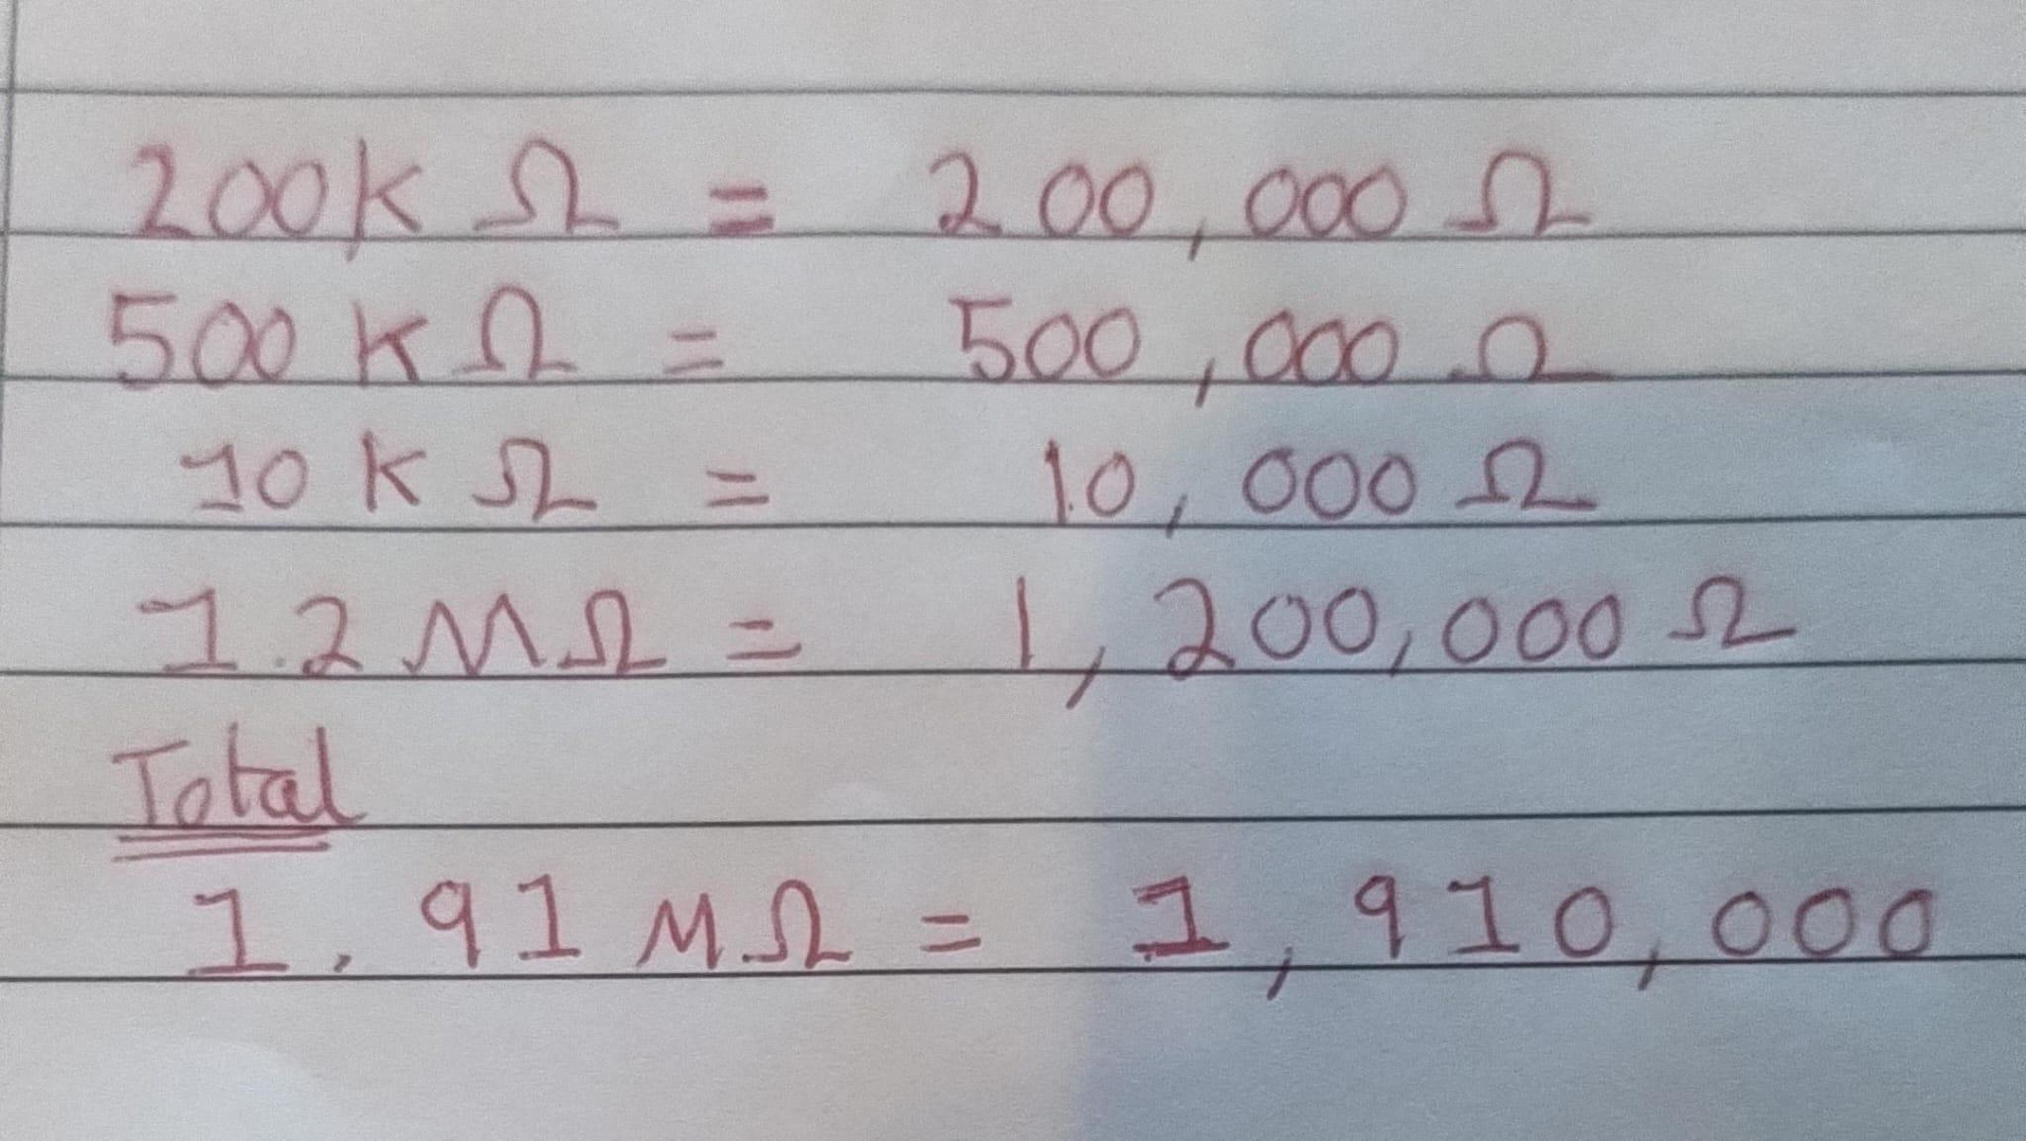

WS Question two
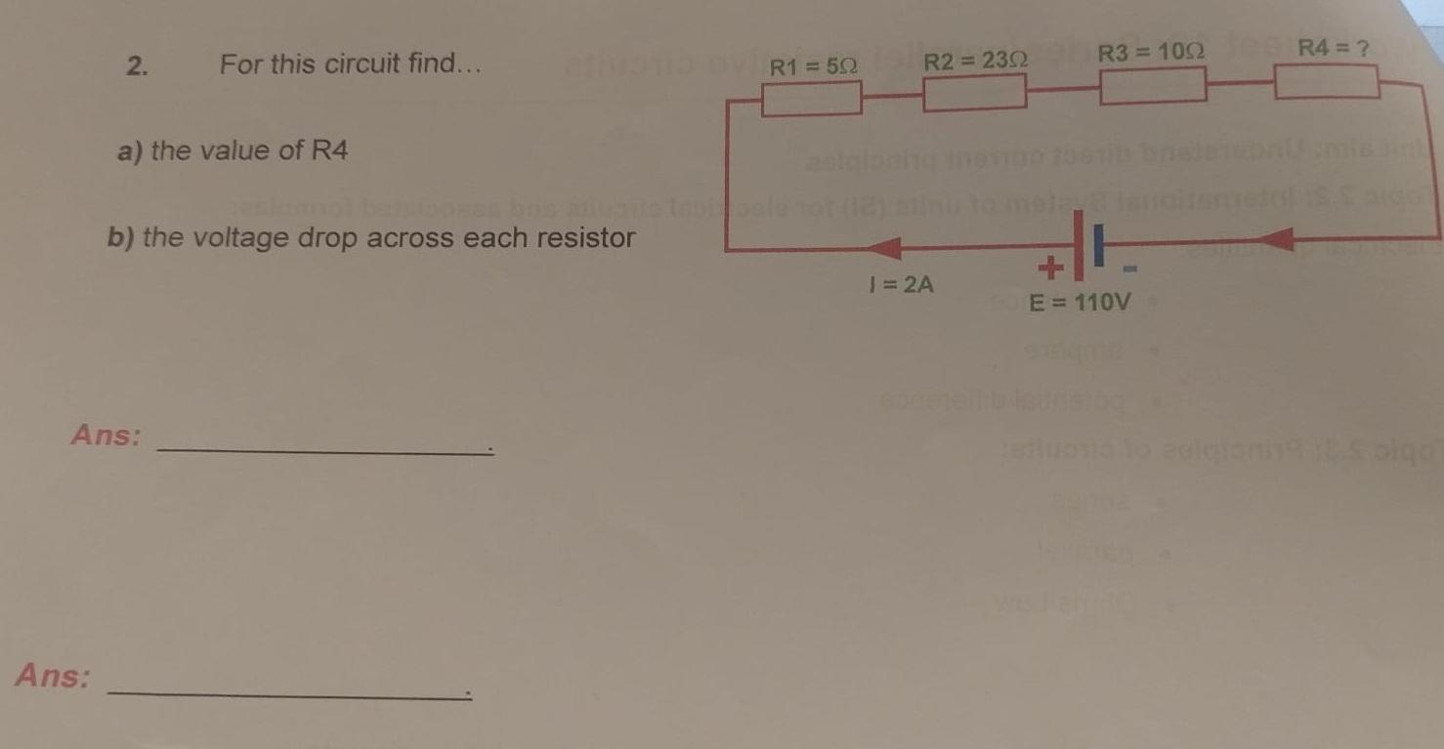

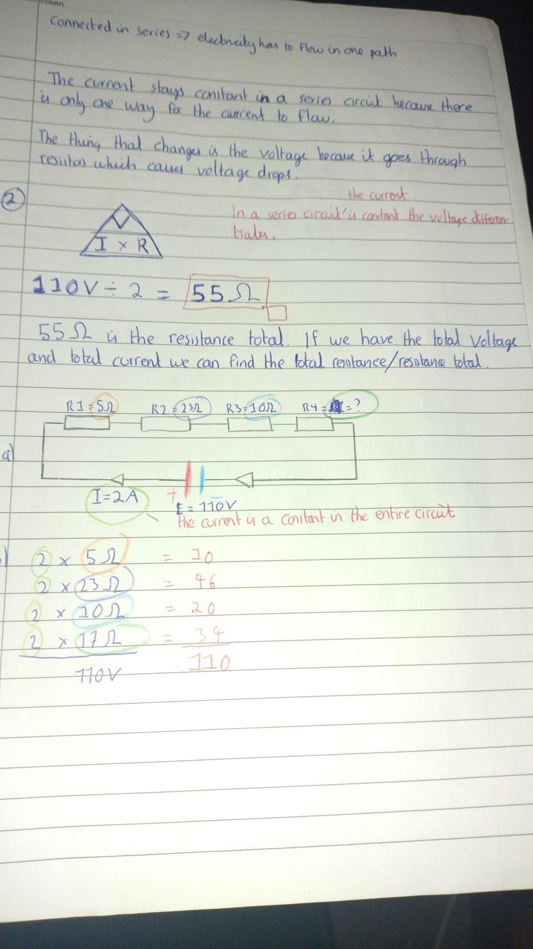

2 a) working out

In a series circuit the current is constant. Whereas, in the series circuit the voltage changes. We have to deduce the value of R4. For the resistances we have:
R1 = 5 ohms,
R2 = 23 ohms,
R3 = 10 ohms,
R4 = ?

The Ohms law triangle.

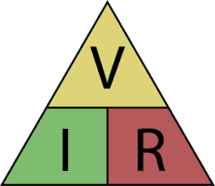

110 V / 2A = 55 ohms
55 Ohms is the total resistance for the entire circuit.

R1 (5 ohms) + R2 (23 ohms) + R3 (10 ohms) = 38 ohms

Hence, R4 = 17 ohms.

Because, 38 + 17 = 55 ohms.

2 b) working out

Voltage drop in a resistor = Current x resistance of resistor

Resistor | Current | Resistance per resistor | Voltage drop per resistor
R1 | 2 | 5Ω | 10
R2 | 2 | 23Ω | 46
R3 | 2 | 10Ω | 20
R4 | 2 | 17Ω | 34
 |  | Voltage drop total | 110V

The way to figure out if you have calculated voltage drop properly. Is that the total voltage drop should equal the voltage of the entire circuit.

WS Question three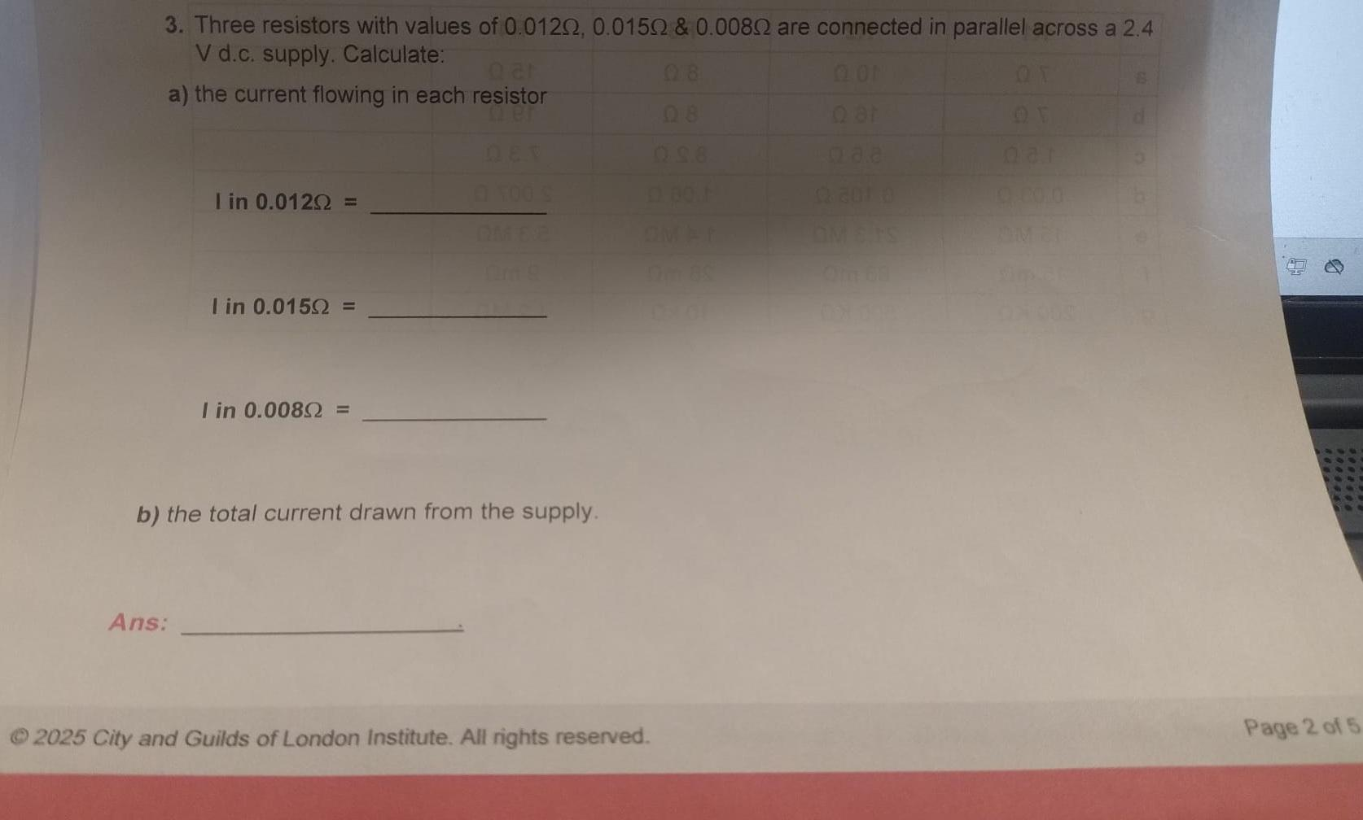

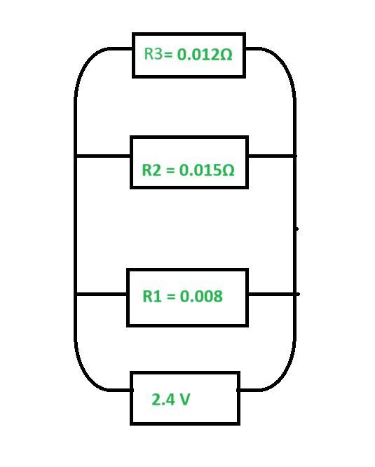

Calculate the current following through each resistor


A) The current flowing in the resistor

R3 => 2.4 V /0.012 ohms = 200 amps
R2 => 2.4 V /0.015 ohms = 160 amps
R1 => 2.4 V /0.008 ohms = 300 amps

B) The total current drawn from the supply

Total Current = Total Voltage / Total Resistance

2.4 / (200 + 160 + 300 = 660)
= 0.035 amps

WS Question four

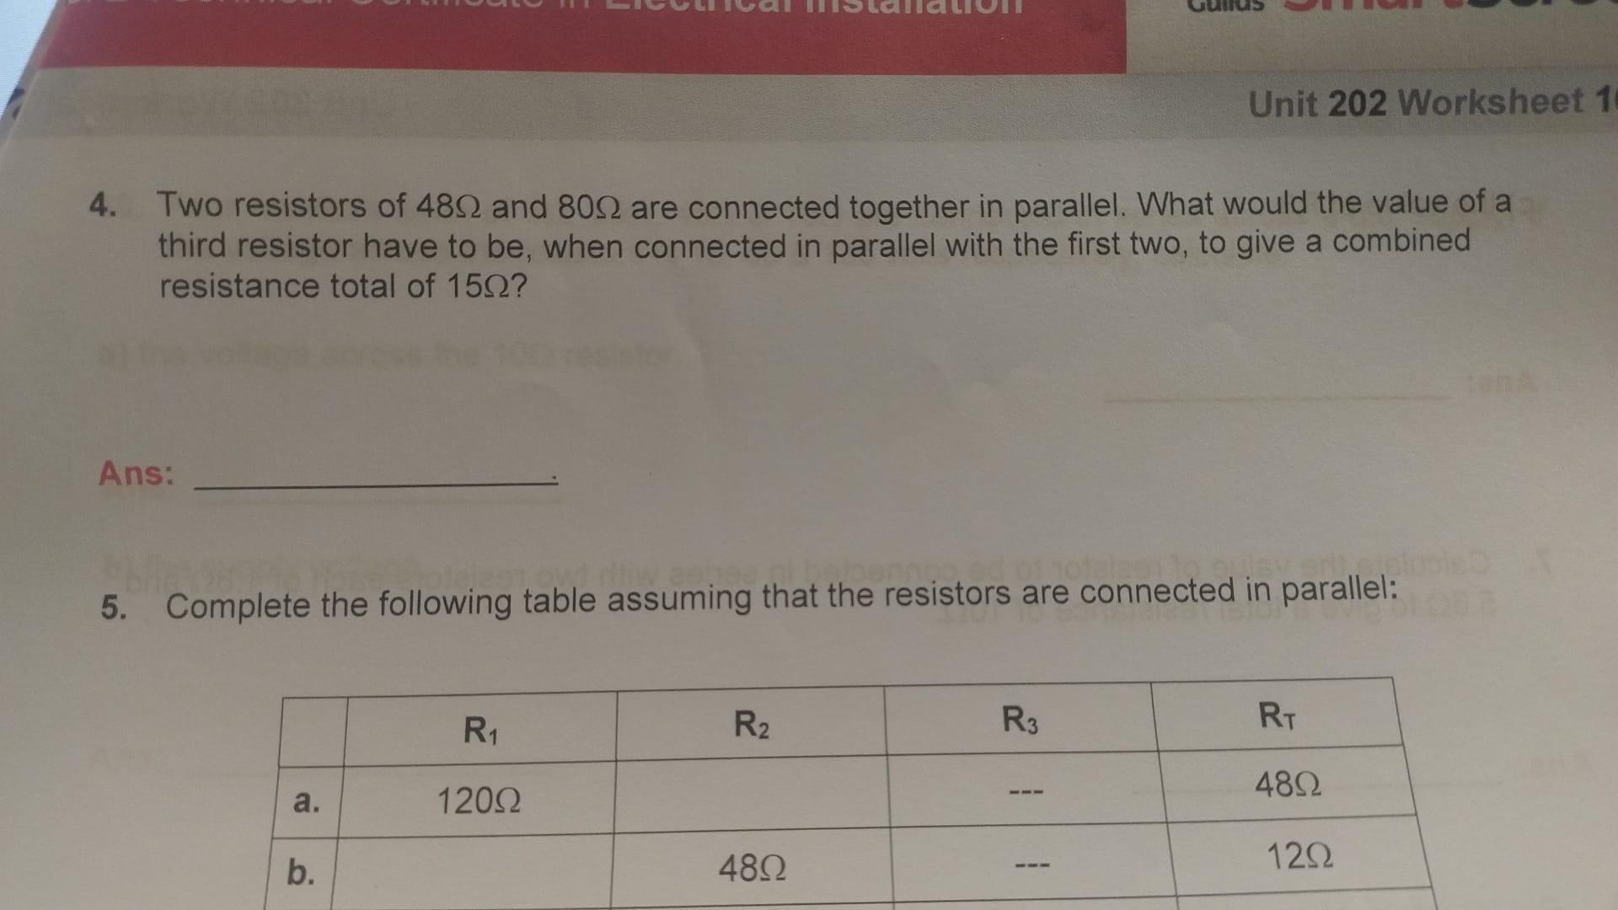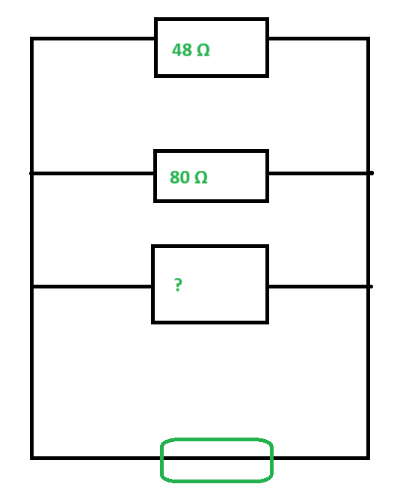

Question four working out
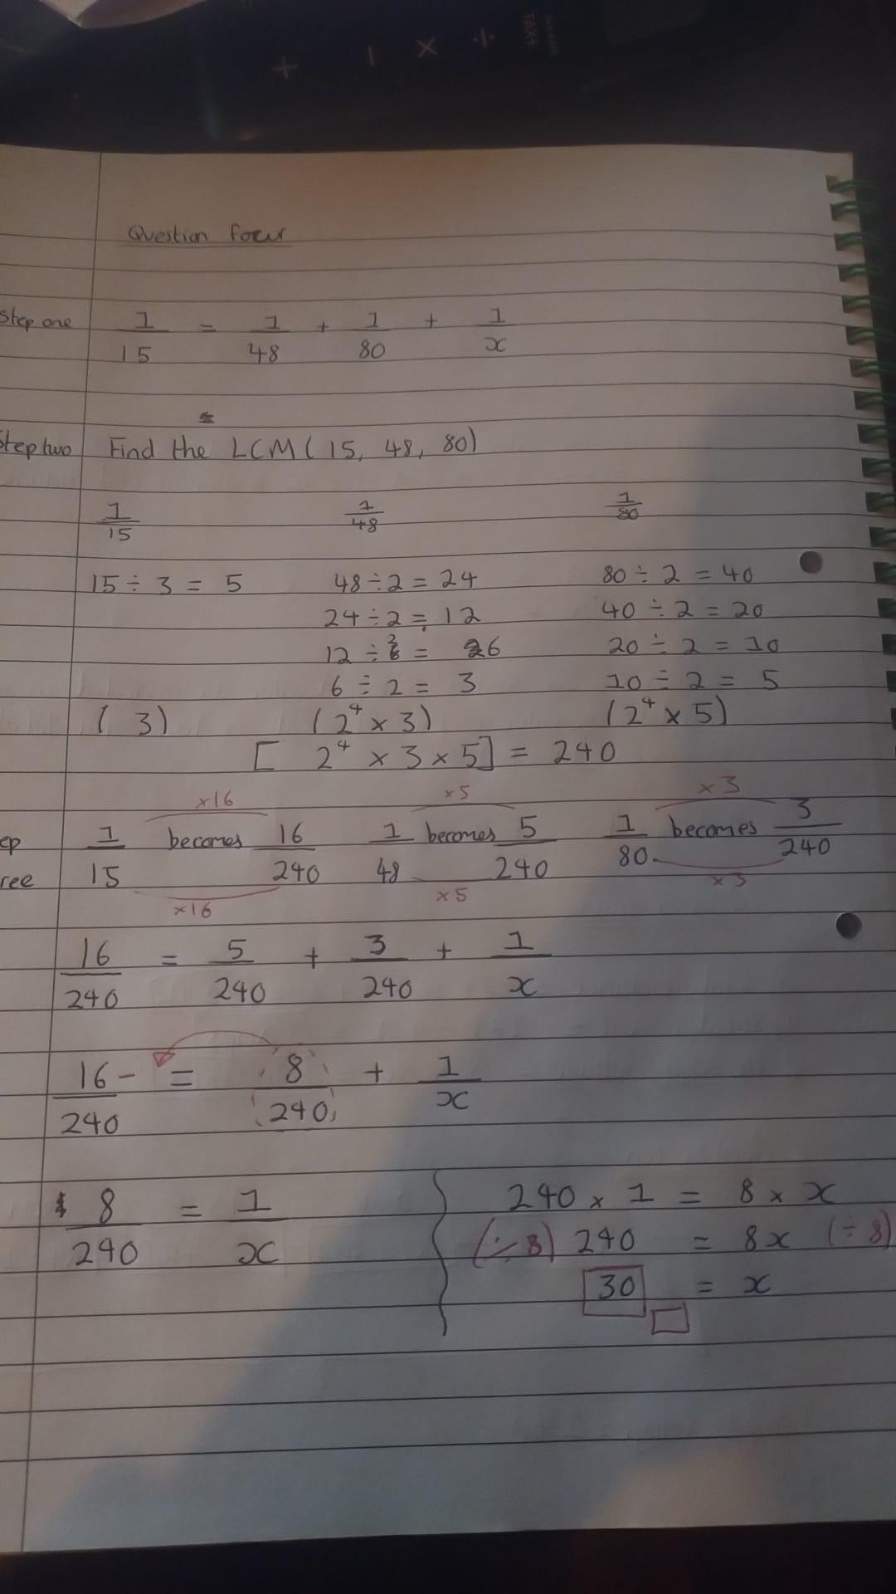

WS Question five

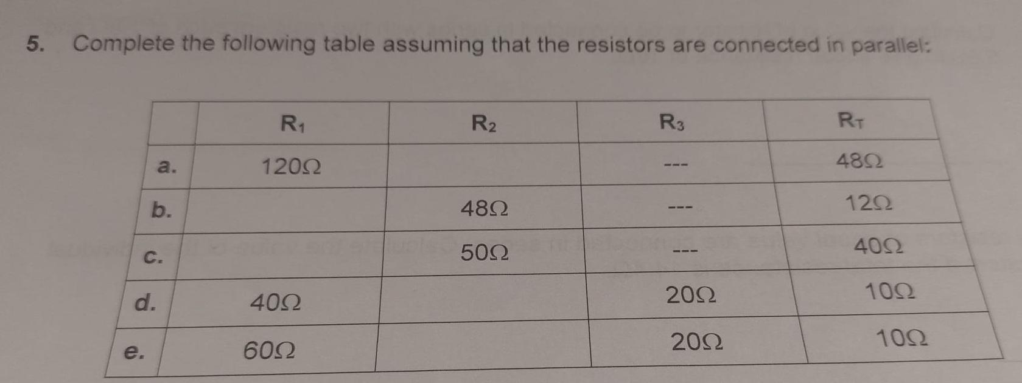

Question five working out

Row A) R₂ = 80 Ω
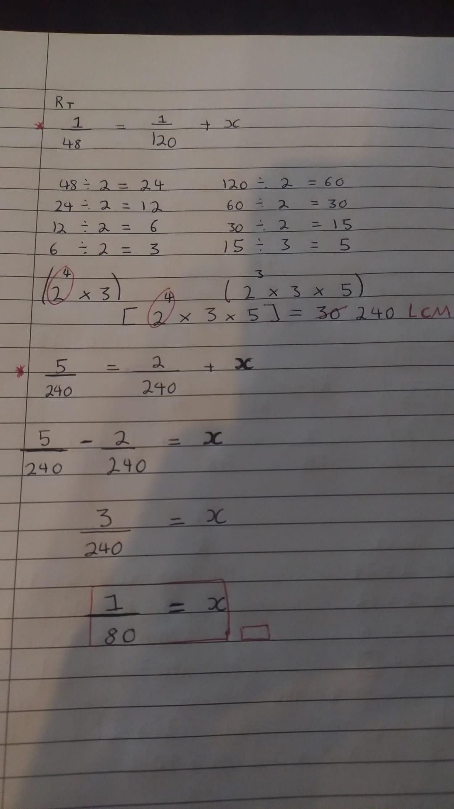

Row B) R₁ = 16 Ω
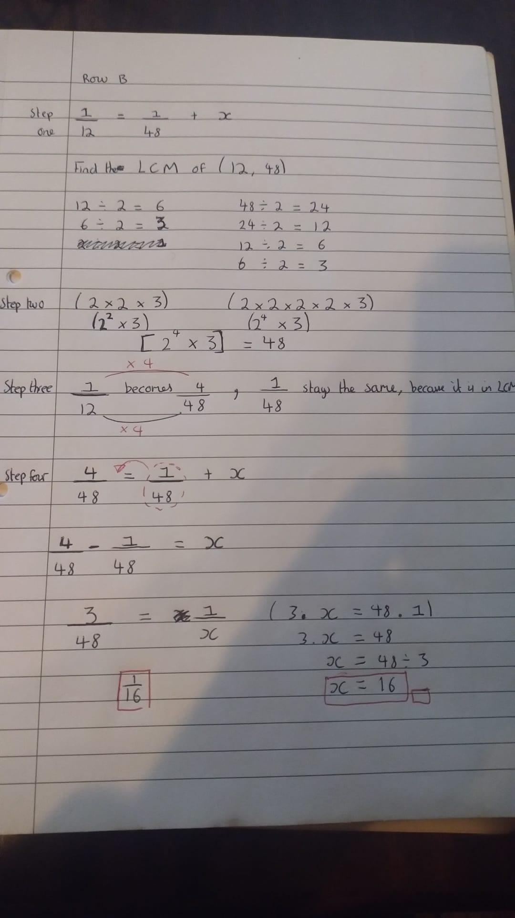

Row C) R₁ = 200 Ω
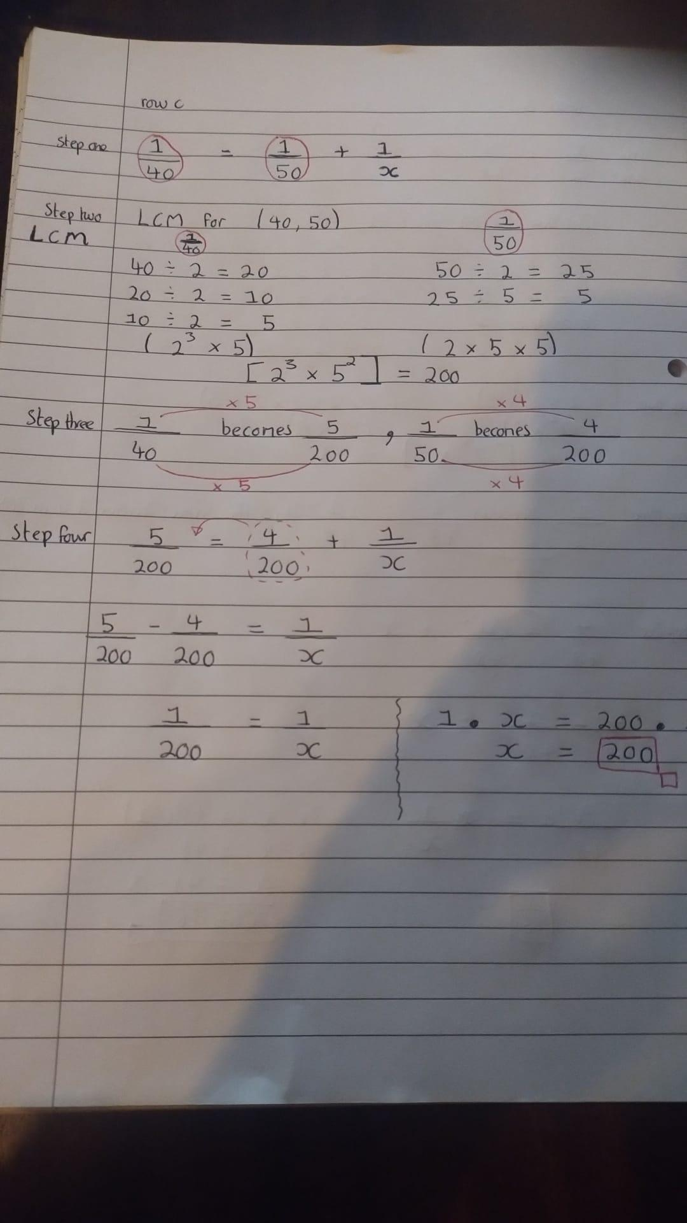

Row D) R₂ = 40Ω

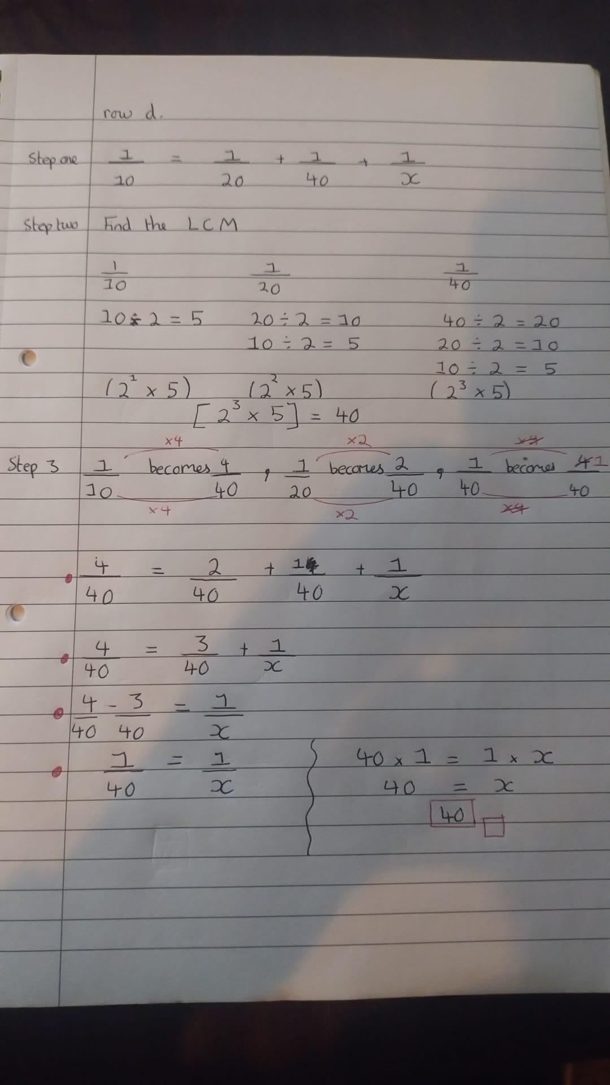

Row E) R₂ = 30Ω

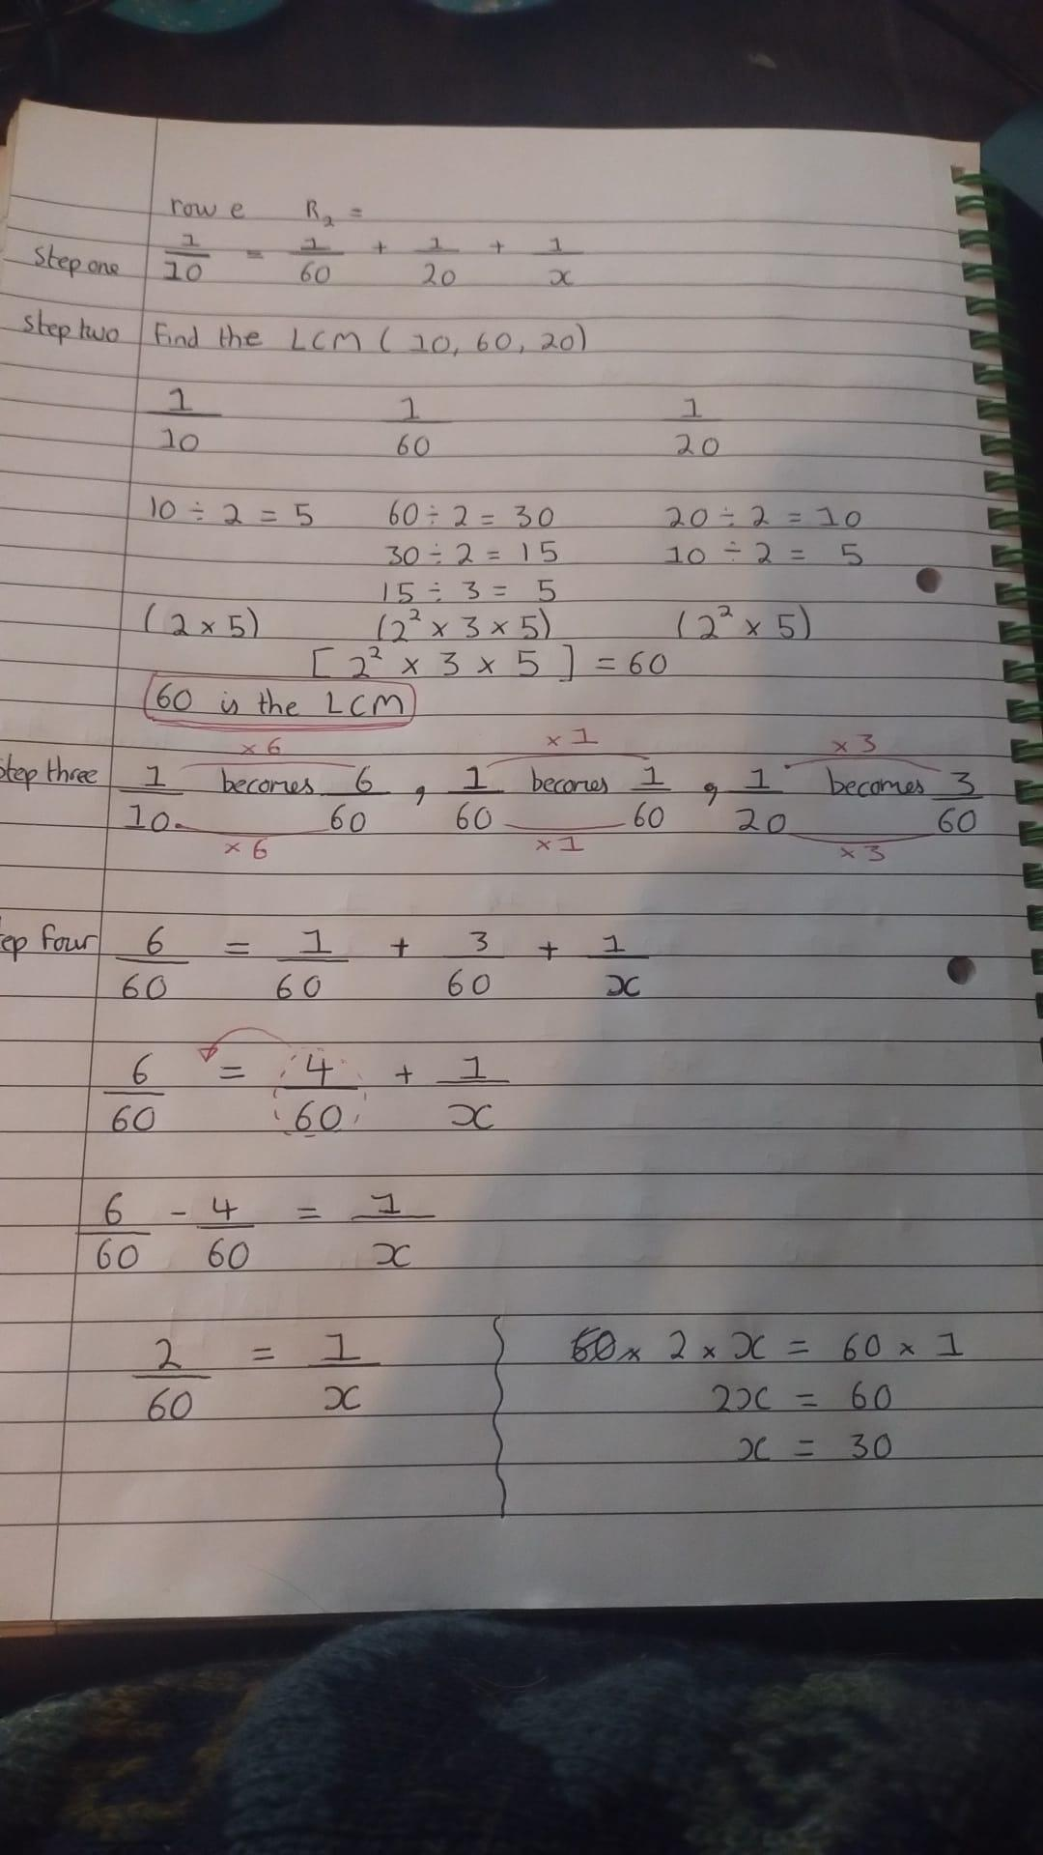

WS Question six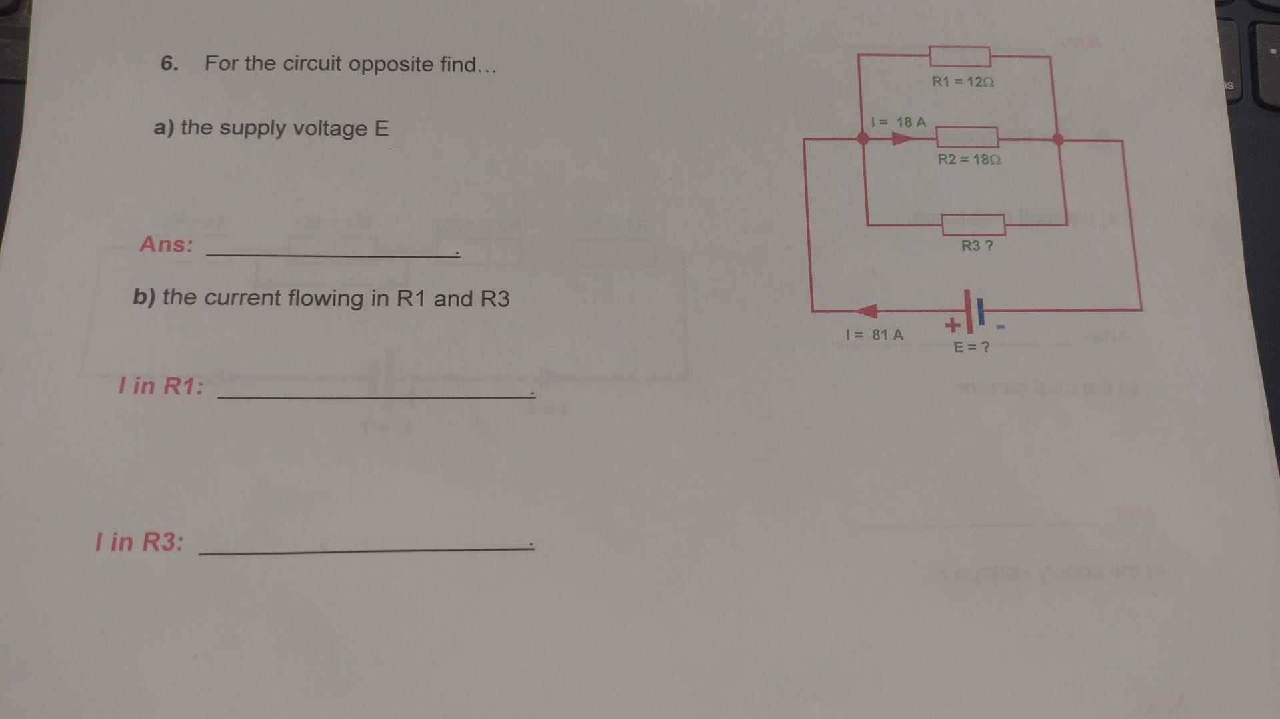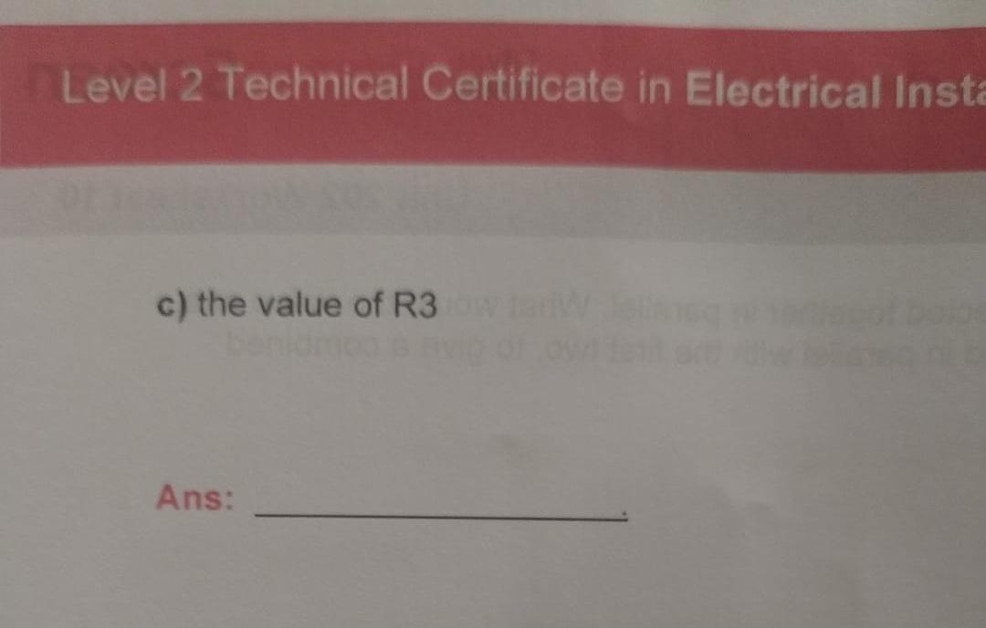

WS Question seven

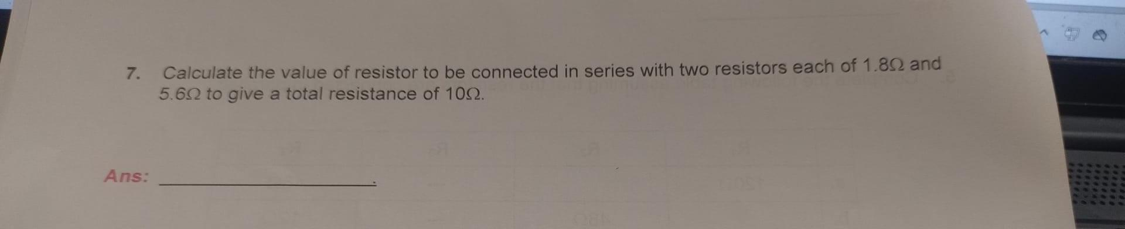

Question seven working out

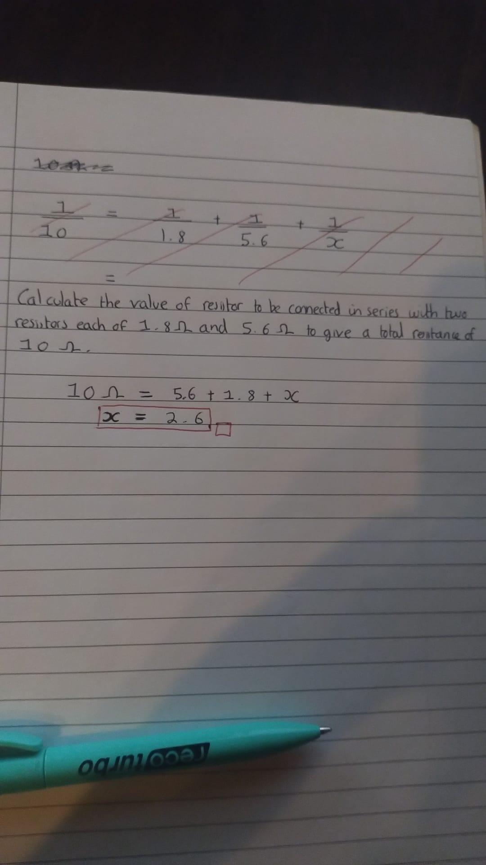

WS Question eight
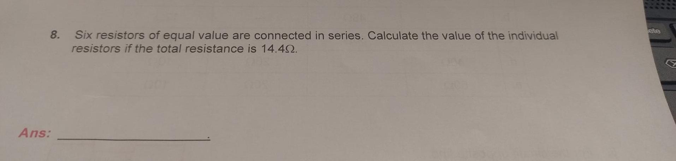

Question eight working out

In a series circuit we add the resistor values together to get the Resistance Total (R_{t}).
In this case we divide 14.4 ohms by 6 to get the individual resistor values. The answer is 2.4.

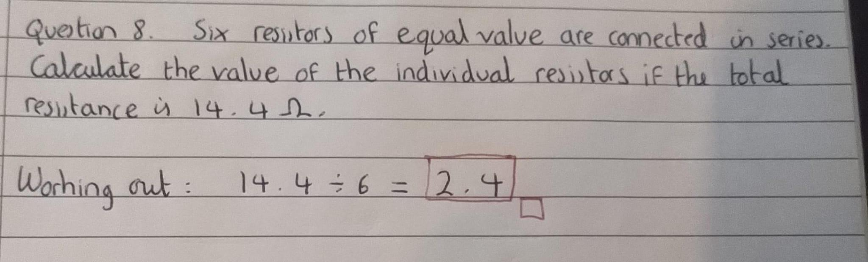

WS Question nine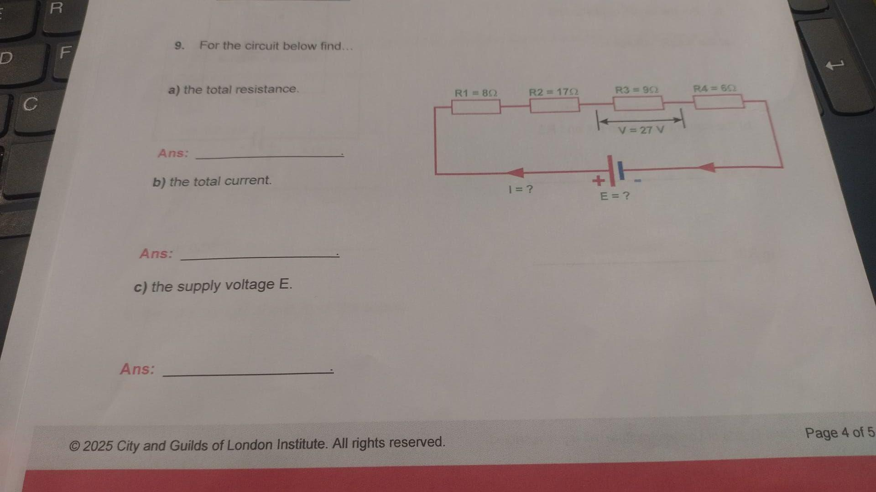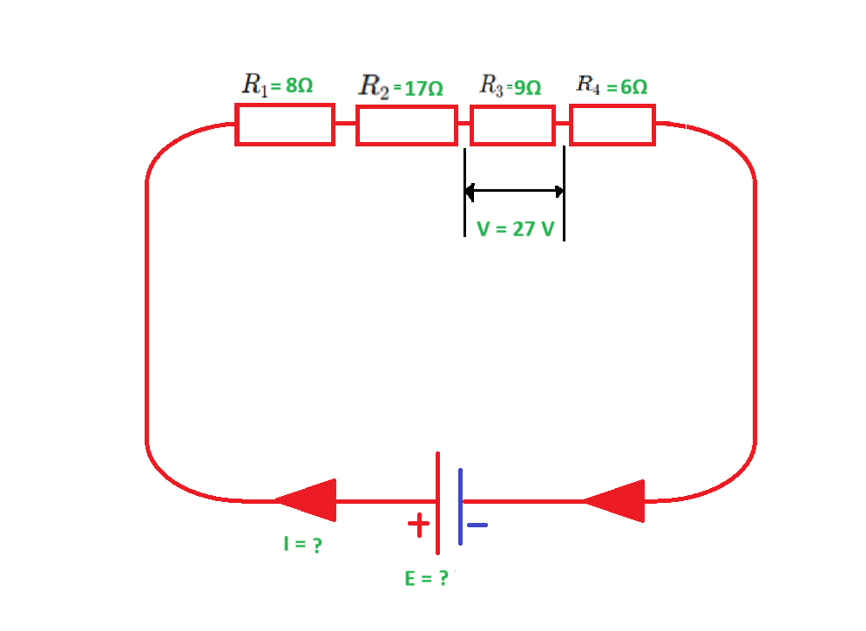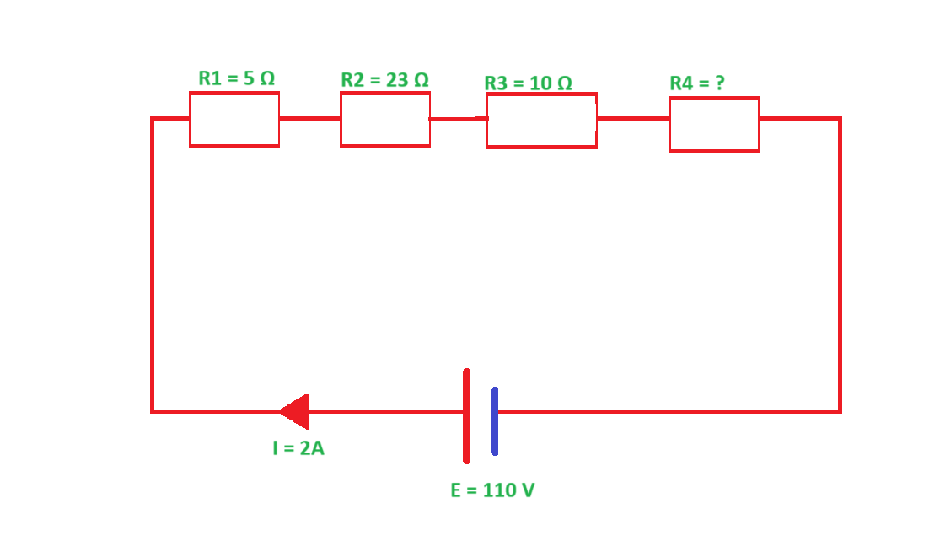

Question nine working out

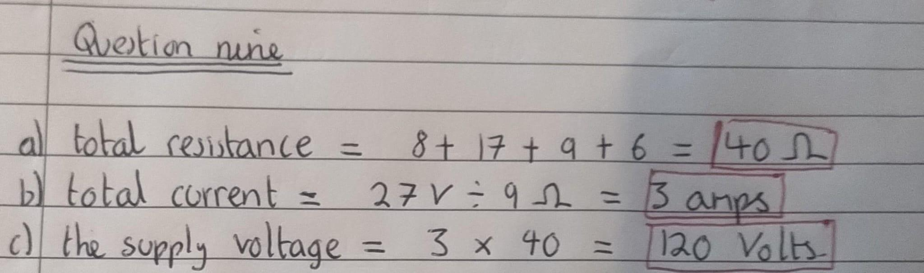

Question ten

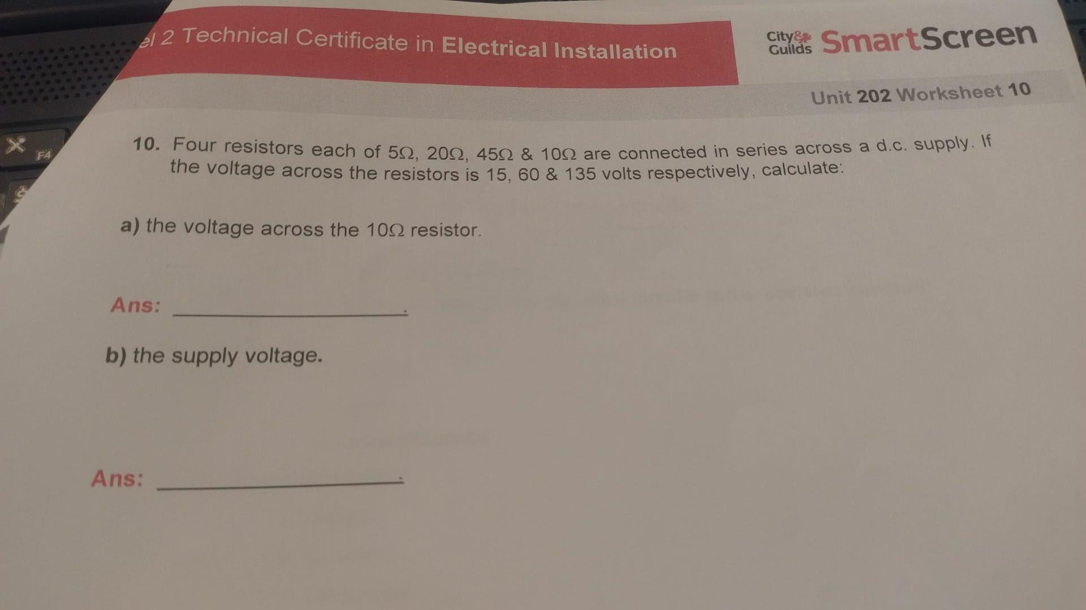

Question ten working out

